#### <Customer> Upgrade Sever Request

**Summary:** This diagram shows Customer sent request Upgrade Sever.

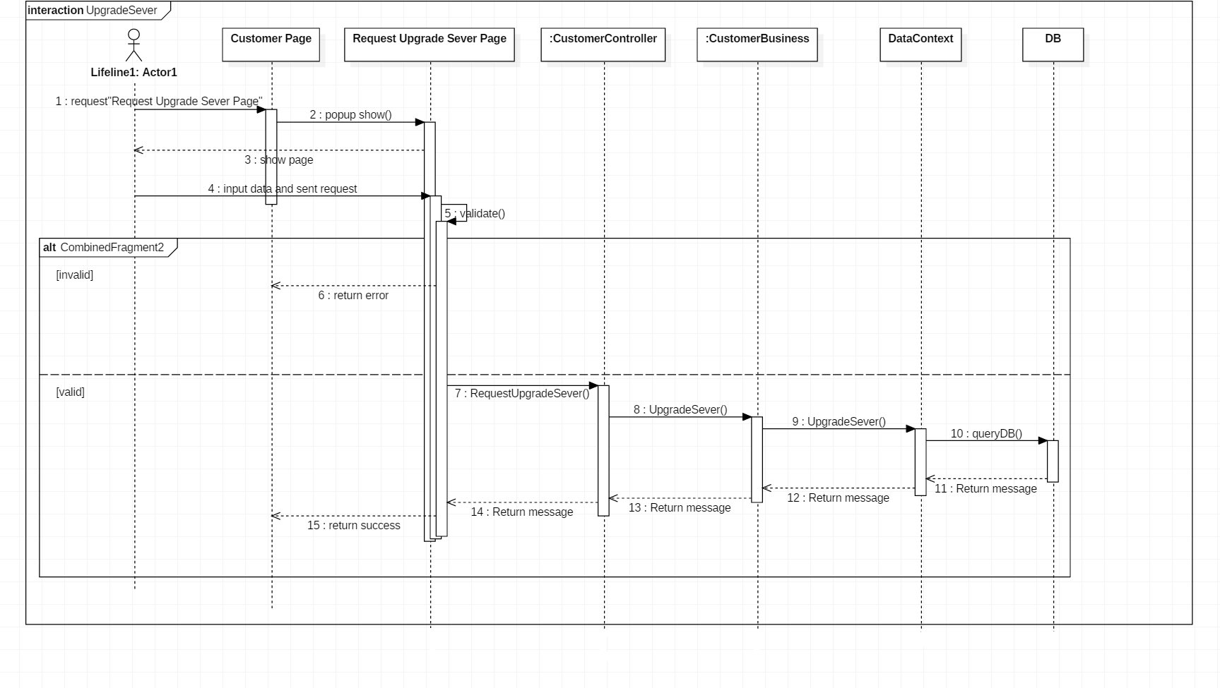

Figure 01: Sequence Diagram <Customer> Upgrade Sever Request

#### <Customer> Return IP Request

**Summary:** This diagram shows Customer sent request Return IP.

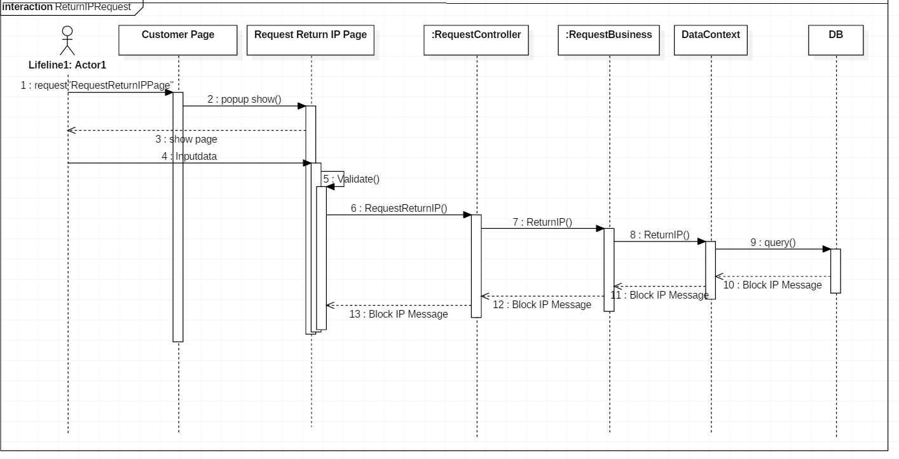

Figure 02: Sequence Diagram <Customer> Return IP Request

#### <Shift head> reject Assign IP

**Summary:** This diagram shows Shift head reject Assign IP.

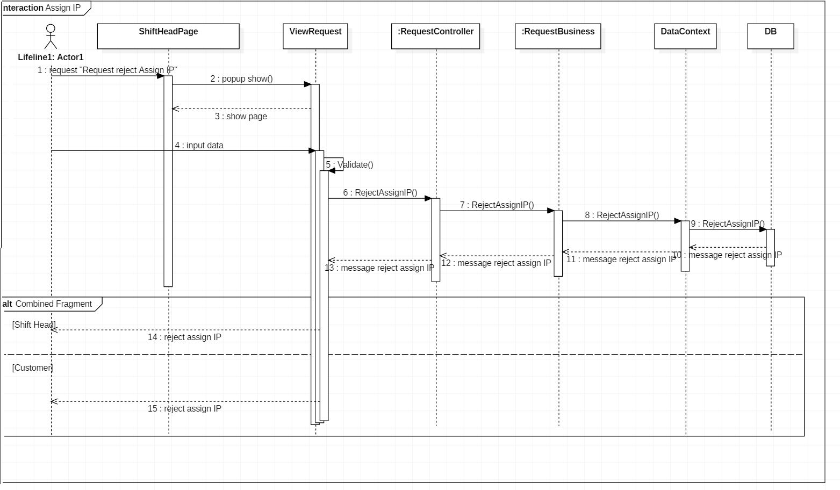

Figure 03: Sequence Diagram <Shift head> reject Assign IP

#### <Shift head> Add new IP Address

**Summary:** This diagram shows Shift head Add new IP Address.

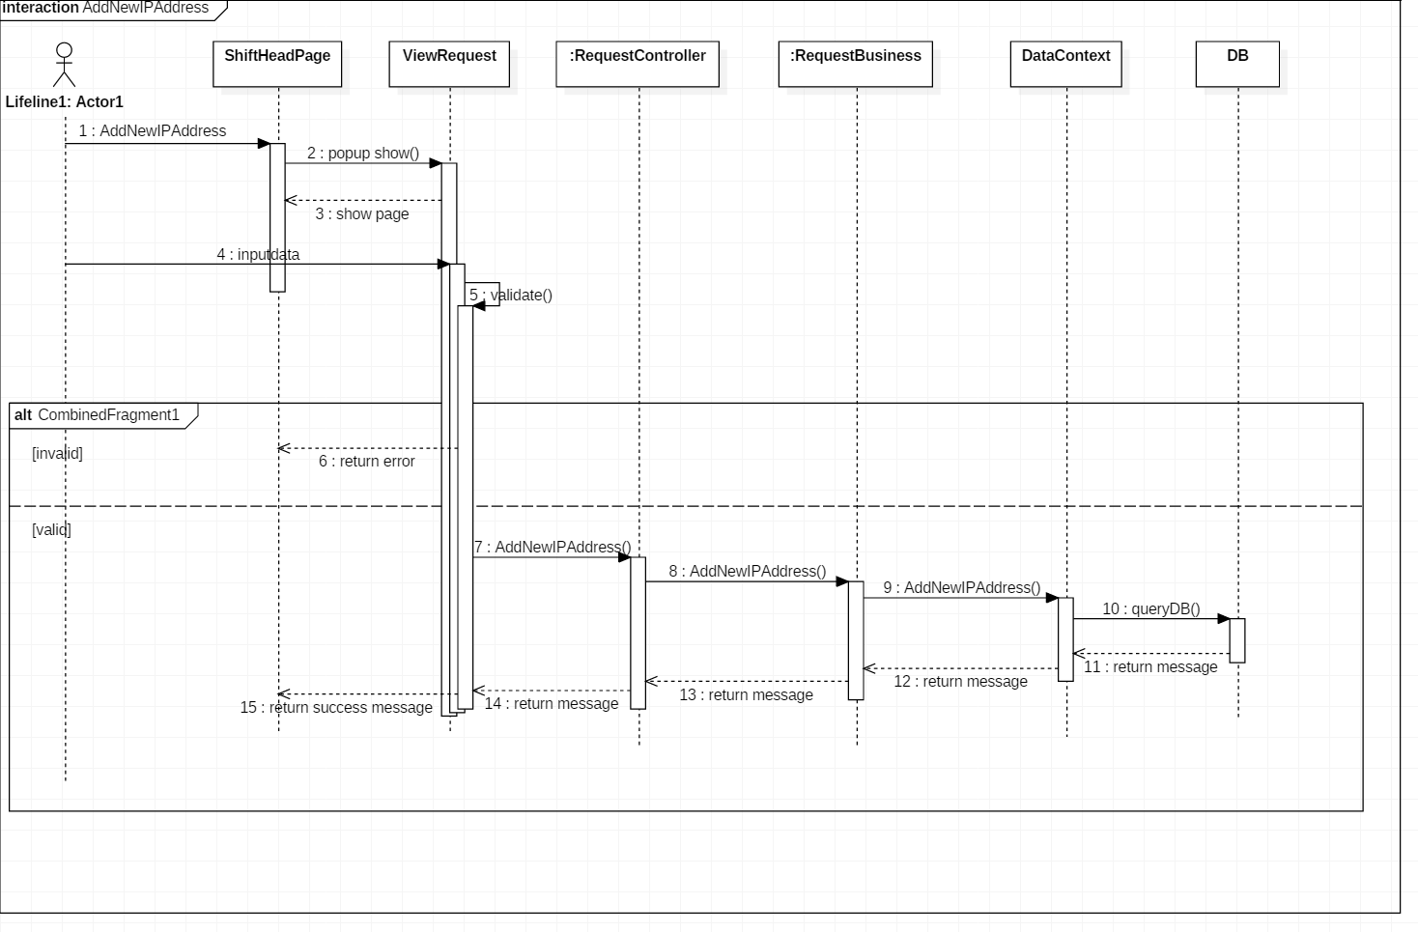

Figure 04: Sequence Diagram <Shift head> Add new IP Address

#### < Shift head > confirm arrival

**Summary:** This diagram shows Shift head confirm arrival.

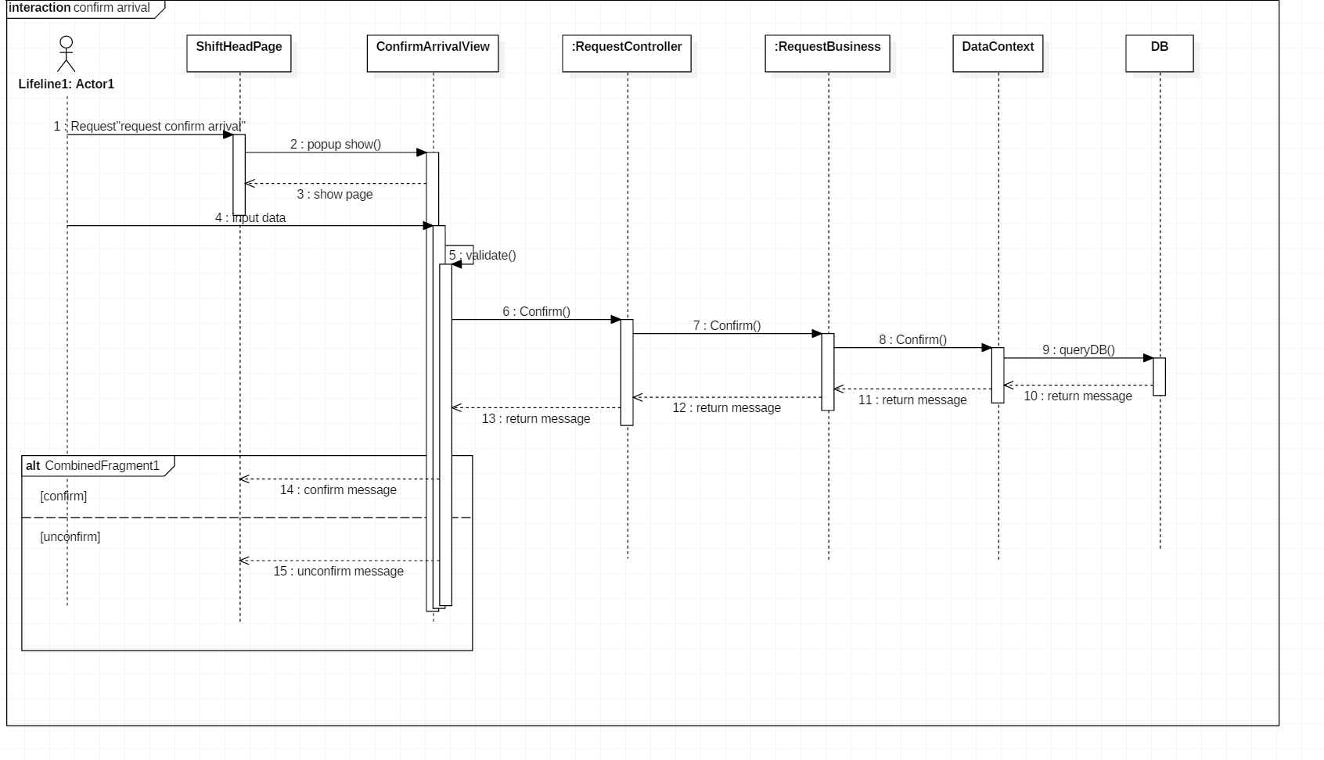

Figure 05: Sequence Diagram <Shift head> confirm arrival

#### < Shift head > Approve Assign IP

**Summary:** This diagram shows Shift head Approve Assign IP.

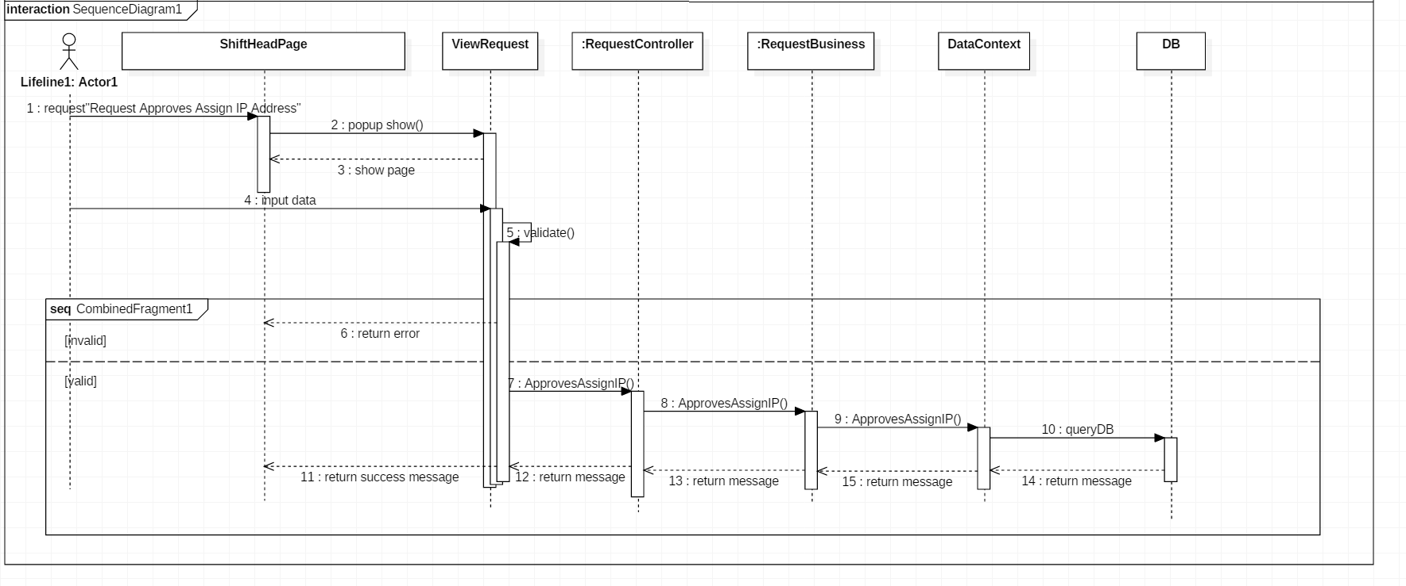

Figure 06: Sequence Diagram <Shift head> Approve Assign IP

#### < Shift head > Write note

**Summary:** This diagram shows Shift head write note.

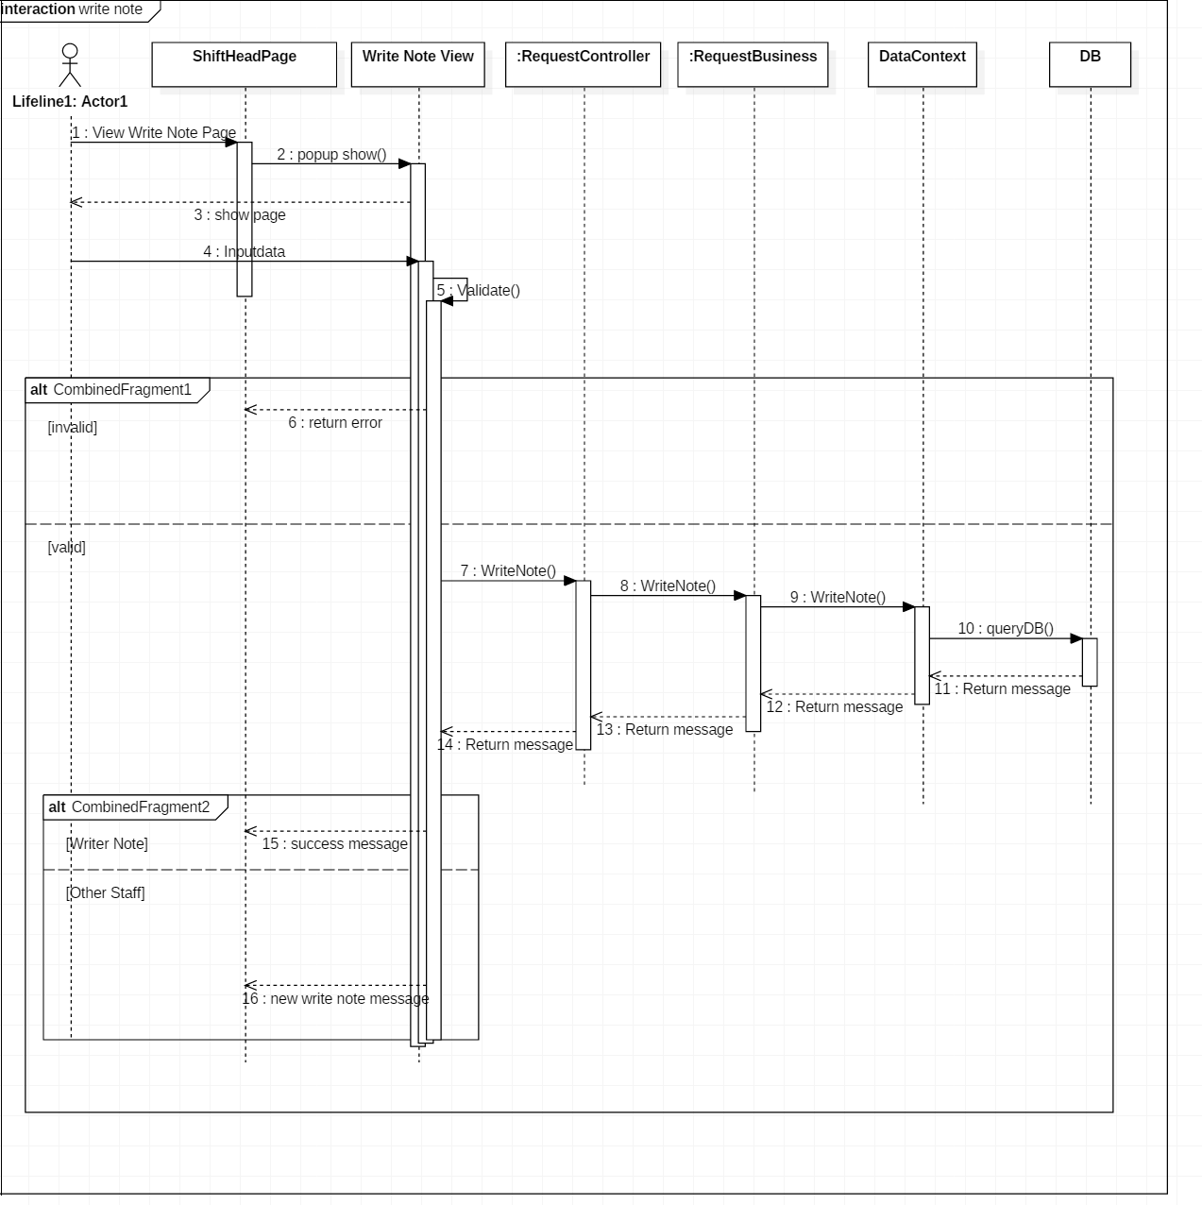

Figure 07: Sequence Diagram <Shift head> Write note